

A Project Report

On

**“Disease Similarity Prediction Using Machine Learning and Web Development”**

Batch Details

|  |  |  |
| --- | --- | --- |
| Sl. No. | Roll Number | Student Name |
| 1 | 20201CEI0136 | I MADHANKUMAR |
| 2 | 20201CEI0121 | SP UDAY KIRAN REDDY |
| 3 | 20201CEI0113 | A V SANTHOSH KUMAR |
| 4 | 20201CEI0112 | P MAHENDRA REDDY |

**School of Computer Science,**

**Presidency University, Bengaluru.**

Under the guidance of,

Ms. Amirtha Preeya

Assistant Professor

School of Computer Science,

Presidency University, Bengaluru

**CONTENTS**

1. Introduction about Project
2. Literature Review
3. Objectives

## Methodology

1. Timeline for Execution of Project
2. Expected Outcomes
3. Conclusion
4. References
5. **INTRODUCTION**

In contemporary healthcare, the battle against diseases like diabetes, heart disease, kidney disorders, and liver ailments is of paramount importance. These conditions, often referred to as the "silent killers," are responsible for a significant number of premature deaths worldwide. To combat these health threats effectively, early detection and predictive analysis are crucial. This project aims to harness the power of advanced computer models and machine learning techniques to identify individuals at risk of these diseases based on their responses to questions and medical test results. Furthermore, it seeks to unravel the underlying factors and markers that play a pivotal role in the development of these health conditions. Machine learning, with its capability to process and analyze extensive medical data, stands as a formidable tool in modern medicine. It has the potential to revolutionize disease diagnosis, prognosis, and treatment personalization, significantly improving healthcare outcomes.

The domain of this “Disease similarity prediction using Machine learning and Web development” revolves around the critical intersection of machine learning, healthcare as well as web development. In an era where data-driven insights are transforming various industries, the medical field has not remained untouched. Leveraging the capabilities of artificial intelligence and machine learning, we aim to address the pressing concern of early disease detection and predictive analysis. Our focus primarily hones in on the prevention and mitigation of prevalent and life-threatening conditions, namely diabetes, heart disease, kidney disorders, and liver ailments.

These diseases are insidious in nature, often manifesting silently within individuals, making their early detection an arduous task. Early intervention, however, can significantly alter the course of these conditions, improving patient outcomes and reducing the burden on healthcare systems. To achieve this, our project employs a multifaceted approach, employing various machine learning algorithms to predict disease risk with a high degree of accuracy.

By conducting a comprehensive analysis of patient responses to specific questions and medical test results, our system can pinpoint potential health risks with remarkable precision. Moreover, it seeks to decipher the intricate web of factors that contribute to the development of these diseases in individuals. In doing so, we endeavor to empower healthcare professionals with the tools and knowledge needed to make more informed and timely decisions, leading to improved patient care and outcomes.

1. **LITERATURE REVIEW**
2. **Disease Prediction from Various Symptoms Using Machine Learning**

**Existing Method:**

The paper compares its methodology with other methodologies reported in the literature, including the use of SVM and KNN models for disease prediction. The weighted KNN algorithm used in the paper achieved an accuracy of 93.5% for disease prediction, which was higher than most other methodologies reported. Khourdifi et al. achieved the highest accuracy of 99.7% using the KNN model for the prediction and classification of heart diseases. Sriram et al. used the Random Forest model and achieved an accuracy of 90.26%.

Mir et al. used the SVM model and achieved an accuracy of 79.13%. The paper highlights the importance of doctors and medical professionals in emergency situations and suggests that the prediction system developed in the paper can be helpful in the diagnosis of diseases, especially in situations where sufficient facilities and resources are unavailable.

**Advantages:**

Advantages of this existing method, the weighted KNN algorithm used in the paper achieved an accuracy of 93.5% for disease prediction, which was higher than most other methodologies reported. The use of multiple ML models for disease prediction allowed for a comprehensive analysis of the dataset, potentially improving accuracy.

**Disadvantages:**

Limitations in this existing method includes that some ML models were dependent on specific parameters and couldn't predict diseases accurately, resulting in lower accuracy percentages.

1. **A data-driven approach to predicting diabetes and cardiovascular disease with machine learning**

**Existing Method:**

Diabetes and cardiovascular disease (CVD) are two prevalent chronic diseases leading to death in the United States. In 2015, approximately 9% of the US population had been diagnosed with diabetes, while another 3% were undiagnosed. About 34% of adults had prediabetes, with almost 90% of them being unaware of their condition. CVD is the leading cause of one in four deaths annually in the US, with approximately 92.1 million American adults living with some form of CVD or its aftereffects. There is a correlation between CVD and diabetes, with at least 68% of people aged 65 or older with diabetes dying of heart disease. Machine learning models have been used in the prediction of diabetes, detection of hypertension in diabetic patients, and classification of patients with CVD among diabetic patients. Successful implementation of machine learning enhances the work of medical experts and improves the efficiency of the healthcare system. Machine learning models can help identify hidden patterns in factors contributing to the identification of patients at risk for diabetes and heart disease.

**Advantages:**

Machine learning models have been successfully used in the prediction and detection of diabetes and cardiovascular disease, enhancing the work of medical experts and improving the efficiency of the healthcare system. The use of supervised learning models allows for the classification of at-risk patients by building models that can predict the category of new observations.

**Disadvantages:**

The study focuses on Type II Diabetes and excludes other types such as gestational diabetes and Type I Diabetes. The models developed in the study utilize survey questionnaire data, which may have limitations in terms of accuracy and reliability compared to other data sources such as electronic health records. The study is based on the National Health and Nutrition Examination Survey (NHANES) dataset, which may have its own limitations and biases.

1. **Chronic kidney disease prediction based on machine learning algorithms**

**Existing Method:**

Data mining techniques are used to find hidden information in large datasets and can be applied in various fields, including healthcare. Machine learning algorithms are particularly suitable for enhancing the accuracy of diagnosis prediction in the healthcare industry due to the availability of electronic healthcare datasets. Several studies have been conducted to extract useful information from datasets related to chronic kidney disease (CKD) using data mining techniques. These studies have utilized various classifiers such as k-nearest neighbors (kNN), naive Bayes (NB), support vector machine (SVM), decision tree (DT), and random forest (RF) to predict CKD. The use of machine learning algorithms, such as neural networks, has also been explored in diagnosing CKD. These algorithms have shown promising results, although the accuracy may be affected by the availability of abundant data. Researchers have also focused on reducing the number of input features for CKD prediction using techniques like principal component analysis (PCA). By utilizing machine learning-based models, high accuracy in CKD prediction has been achieved. The research on CKD prediction in this paper builds upon previous studies by investigating the potential of different machine learning algorithms for early diagnosis of CKD. The authors have narrowed down the list of input features and tested 12 different machine learning-based classifiers, achieving excellent performance in terms of accuracy, precision, recall, and F1-score. The dataset used in this research is based on the UCI machine learning repository and includes 24 input features. The authors have also utilized PCA to further improve the accuracy of the XgBoost classifier

**Advantages**:

The use of machine learning algorithms in predicting chronic kidney disease (CKD) has shown promising results in terms of accuracy, precision, recall, and F1-score. The research investigates the potential of different machine learning approaches for early diagnosis of CKD, enhancing the accuracy of prediction. The study narrows down the list of input features and tests 12 different machine learning-based classifiers, providing a comprehensive analysis of their performance. The utilization of predictive modeling and better measures of attributes through machine learning improves the accuracy of CKD prediction.

**Disadvantages:**

The research does not provide a comparison with other existing methods or studies in the field of CKD prediction, limiting the assessment of its novelty and effectiveness in comparison to previous approaches. The study does not discuss the potential challenges or limitations of using machine learning algorithms for CKD prediction, such as data availability, interpretability of results, or generalizability to different populations.

1. **Heart Diseases Prediction based on Stacking Classifiers Model**

**Existing Method:**

Numerous studies have demonstrated the effective application of ML models in the detection of heart diseases. The UCI Heart Disease Dataset from UCI Machine Learning Repository is widely used in this research area. Verma et al. proposed a hybrid model using particle swarm optimization (PSO) and two machine learning classifiers for the prediction of heart disease. Christalin Latha and Carolin Jeeva designed a hybrid model that implements four ML classification algorithms and incorporates various ensemble learning methods. In this research work, the dataset selected is the UCI Heart Disease Dataset, which is available online and consists of 303 instances of records. Traditional classifiers have shown to perform well with proper model generation, and their performance can be improved by implementing various techniques. The proposed model in this paper achieved an accuracy of 92%, precision of 92.6%, sensitivity of 92.6%, and specificity of 91%. The performance of the proposed model was evaluated using various metrics, including accuracy, precision, recall, F1-scores, and area under the ROC curve values.

**Advantages:**

The proposed model provides faster analysis and prediction of heart diseases, reducing the time for diagnosis and enhancing results. It leverages electronic health records (EHRs) and machine learning algorithms to improve prediction accuracy.

**Disadvantages:**

The limitations of the proposed model are not explicitly mentioned in the provided sources. Further research may be needed to evaluate its performance on larger datasets and in real-world clinical settings.

1. **Machine learning based diabetes prediction and development of smart web application**

**Existing Method:**

Various supervised machine learning algorithms have been used by researchers for diabetes prediction, including Radial basis function (RBF) kernel SVM, artificial neural network (ANN), multifactor dimensionality reduction (MDR), linear SVM, k-NN, Naive Bayes (NB), Decision Tree (DT), Adaboost, and Random Forest (RF). Logistic Regression (LR) has been used to recognize the risk factors for diabetes based on p value and odds ratio (OR). Different machine learning models, such as Support Vector Machines, logistic regression, gradient boosting, and random forest, have been evaluated for the classification of cardiovascular, prediabetes, and diabetes detection. Machine learning techniques like SVM, Random Forest, and full-scale neural network have been used for diabetes prediction and identification. The proposed model in this paper integrates various machine learning algorithms, including Naive Bayes, Decision Tree, Random Forest, Support Vector Machines, Logistic Regression, Gradient Boosting, and k-nearest neighbor. The model is tested and evaluated using two different datasets with various attributes, including glucose level, insulin level, blood pressure, BMI, and age. Pre-processing techniques, such as removing outliers, dealing with missing values, data standardization, and encoding, are applied to improve the performance of the model.

**Advantages:**

Advantages of existing methods include the ability to predict diabetes accurately and efficiently, improved data quality through preprocessing techniques, and the use of multiple datasets to enhance model robustness.

**Disadvantages:**

Limitations of existing methods include performing better on specific datasets but not demonstrating promising accuracy on other datasets, and the need for further investigation of machine learning models, datasets, and preprocessing strategies to improve accuracy.

1. **Diabetes Disease Prediction Using Machine Learning on Big Data of Healthcare**

**Existing Method:**

The literature survey in this paper focuses on the use of Big Data Analytics and Machine Learning in the healthcare domain. It highlights the challenges and gaps in existing approaches and emphasizes the need for smart learning healthcare systems. Various computing techniques have been applied in the healthcare domain, including the use of big data analytics to uncover additional value from healthcare data. The survey discusses research trends and challenges in implementing Big Data Analytics, such as improving research phases and using big data to study patient behavior. It also explores the extraction of useful information from Electronic Health Records, the use of intelligent design for health assessment, and the application of machine learning for disease diagnosis and prognosis. The survey compares different machine learning algorithms, such as SVM, Decision Tree, Naive Bayes, and CART, for disease prediction, highlighting the preference for SVM due to its higher accuracy.

**Advantages:**

Early disease diagnosis and prediction using machine learning algorithms. Improved decision-making for practitioners in disease diagnosis. Discovery of interesting patterns in disease data using statistical medical data and machine learning algorithms. Uncovering additional value from healthcare data through big data analytics. Efficient platform for simplification of complex health assessment and monitoring procedures.

**Disadvantages:**

Limitations in accuracy of prediction models. Time-consuming training process for machine learning algorithms. The need for feature selection in the prediction models.

1. **Interactive Thyroid Disease Prediction System Using Machine Learning Technique**

**Existing Method:**

The paper discusses the use of machine learning techniques for thyroid disease prediction, specifically focusing on algorithms such as support vector machine (SVM), K-NN, and decision trees. Various authors have used data mining techniques to diagnose thyroid diseases, including algorithms like random forest, decision tree, naive Bayes, SVM, and ANN. Machine learning models have been applied to analyze complex and diverse data related to thyroid disorders, showing potential for personalized medicine. Supervised learning is used in the paper's methodology, where a function is inferred from labeled training data to map new instances.

**Advantages:**

The use of machine learning techniques allows for accurate prediction of thyroid disease based on patient data. The proposed method utilizes data cleansing techniques to ensure the accuracy and reliability of the input data for analysis. The machine learning algorithms used, such as support vector machine (SVM), K-NN, and decision trees, have been widely used in healthcare and have shown good accuracy in disease prediction.

**Disadvantages:**

The paper does not provide a comprehensive comparison of the performance of different machine learning algorithms, limiting the understanding of their relative strengths and weaknesses. The paper does not discuss potential limitations or challenges in implementing the proposed method in real-world clinical settings, such as data availability, scalability, and interpretability.

1. **Designing Disease Prediction Model Using Machine Learning Approach**

**Existing Method:**

The paper discusses the use of data mining and machine learning algorithms, specifically K-Nearest Neighbor (KNN) and Convolutional Neural Network (CNN), for disease prediction based on symptoms of the patient. The authors mention that machine learning algorithms such as Naive Bayes and Apriori are highly useful for disease diagnosis on small volume data, but they acknowledge the challenge of classifying large medical datasets. The paper describes the steps involved in the proposed system, including converting the dataset into vector form, word embedding, and using a convolutional layer for disease prediction. The authors compare the accuracy and time required for classification between KNN and CNN algorithms, concluding that CNN is better in terms of both accuracy and time. The paper also mentions the use of 2D and 3D graphs and pie charts for visualization purposes in the clinical decision-making system.

**Advantages:**

The use of data mining and machine learning algorithms, specifically KNN and CNN, allows for accurate prediction of diseases based on symptoms of the patient. The CNN algorithm, which considers both structured and unstructured data, provides higher accuracy in disease prediction compared to the KNN algorithm. The proposed system includes visualization techniques such as 2D and 3D graphs and pie charts, which can aid in understanding and interpreting the disease prediction results.

**Disadvantages:**

The existing method in the paper has limitations in handling large datasets, which is a challenge in the growing field of medical data. The KNN algorithm requires more time and memory compared to the CNN algorithm. The paper does not provide a comprehensive literature review, which may limit the understanding of the existing methods and their drawbacks.

1. **Cardiovascular Disease Prediction Using Machine Learning Models**

**Existing Method:**

Various studies have focused on heart disease prediction using different data mining techniques. The decision tree classifier has shown good performance compared to other models in terms of classification accuracy. A system has been developed to help medical professionals evaluate the risk of heart disease based on clinical data. Machine learning algorithms such as ANN, KNN, k-means, and K-medoids have been trained on the Cleveland dataset for heart disease prediction. Higher BMI in childhood increases the risk of coronary heart disease in adulthood. Increased BMI in adolescence increases the risk of cardiovascular mortality in adulthood. Higher BMI is associated with an increased risk of various cardiovascular conditions. BMI is a significant factor in predicting cardiovascular disease.

**Advantages:**

Machine learning models are promising in assisting with cardiovascular disease prediction, as they can analyze massive amounts of healthcare data. The inclusion of BMI as a feature in the prediction model is highlighted as significant, improving the accuracy of the prediction. Different machine learning algorithms were used to develop the model, allowing for a comprehensive analysis of the data. The decision tree algorithm was found to be efficient and had the highest accuracy in predicting cardiovascular disease.

**Disadvantages:**

The testing accuracy in some models was slightly greater than the training accuracy, which is not ideal as the testing accuracy should generally be lower. The paper does not explicitly mention any limitations or challenges faced during the development of the machine learning models.

1. **Application of Machine Learning in Disease Prediction**

**Existing Method:**

The paper discusses the increasing application of machine learning in the field of medical diagnosis, specifically in disease prediction. It highlights the importance of early detection of diseases such as breast cancer, heart diseases, and diabetes, which can significantly improve patient outcomes. The paper applies different classification algorithms, including Logistic Regression, Decision Trees, Random Forest, Support Vector Machine (SVM), and Adaptive Boosting, on three separate databases of diseases for prediction. Feature selection is performed using backward modeling and the p-value test. The results of the study support the idea of using machine learning for early disease detection and show promising prediction accuracies for heart disease, diabetes, and breast cancer.

**Advantages:**

The application of machine learning in medical diagnosis aids in early detection of fatal diseases, increasing the survival rate of patients significantly. The use of machine learning algorithms, such as Logistic Regression, Support Vector Machine (SVM), and Adaptive Boosting, shows promising results in disease prediction and early detection. The proposed method in the paper exhibits better accuracy than existing methods, with prediction accuracies of 87.1% in Heart Disease detection, 85.71% in Diabetes prediction, and 98.57% in Breast Cancer detection.

**Disadvantages:**

The paper does not mention any specific disadvantages or limitations of the applied machine learning algorithms or the proposed method. Further research and evaluation may be needed to identify any potential limitations or challenges in implementing these algorithms in real-world medical settings.

1. **OBJECTIVES**

In the ever-evolving landscape of healthcare, the integration of technology and artificial intelligence has been transformative. Our project aims to develop a user-friendly web or mobile application that empowers patients to take control of their health. Leveraging advanced machine learning algorithms, this application seeks to accurately identify potential diseases based on patient-reported symptoms, provide medication recommendations, and guide users toward timely medical consultations. Furthermore, it will equip users with vital information on preventive measures, self-care tips, and valuable healthcare resources. This holistic approach to healthcare management is poised to not only improve the well-being of individuals but also reduce the burden on healthcare systems.

The modern healthcare system is characterized by its complexity, with patients often struggling to navigate the labyrinth of medical information, symptoms, and treatment options. Our project sets out to address these challenges by creating a user-friendly web or mobile application, which we refer to as the "Health Companion," designed to be an accessible and reliable healthcare resource for everyone.

**Key Objectives:**

1. Symptom-Based Disease Identification:

- The primary objective of our application is to enable users to input their symptoms, thus initiating a symptom-based disease identification process.

- Advanced machine learning algorithms will be employed to accurately match symptoms with potential diseases.

2. Personalized Medication Recommendations:

- The application will provide personalized recommendations for appropriate medications based on the identified diseases.

- Users can access essential information about these medications, including dosages, side effects, and usage instructions.

3. Guidance on Seeking Medical Consultations:

- The application will guide users in seeking timely medical consultations by highlighting the urgency and importance of addressing certain symptoms.

- It will connect users with healthcare professionals for virtual consultations or appointments.

4. Empowering Users with Information:

- Our application will empower users by providing comprehensive information on common preventive measures for various health conditions.

- Self-care tips and best practices will be shared to encourage responsible health management.

5. Access to Valuable Resources:

- To ensure a holistic approach to healthcare, the application will offer users access to a wealth of resources, such as articles, videos, and community forums.

- These resources will facilitate a deeper understanding of health conditions and their management.

6. Time and Cost Reduction:

- A key benefit of our proposed method is its ability to accurately predict outcomes based on user-reported symptoms.

- This not only accelerates the diagnosis process but also contributes to cost reduction by minimizing unnecessary medical tests.

7. Features and Functionality:

Our application will encompass a range of features to fulfil the objectives mentioned above, including:

- User-friendly symptom input interface.

- A powerful machine learning engine for symptom-disease matching.

- Medication database and recommendations.

- Health professional consultation booking system.

- Educational content and resources.

- A comprehensive user profile for tracking health history.

- Timely notifications and reminders.

- Community and support forums.

1. User Experience and Accessibility:

The "Health Companion" application is designed to be accessible to all, ensuring a seamless user experience. It will be available as both a web application and a mobile app for various platforms (iOS and Android). The user interface will be intuitive, guiding users through the process of symptom input, disease identification, and beyond.

1. Ethical Considerations:

Respecting patient privacy and autonomy is of paramount importance. The application will strictly adhere to data protection regulations, and user data will be anonymized and securely stored. Additionally, it will not replace professional medical advice but will serve as a valuable supplementary tool.

Our project aims to revolutionize healthcare by providing an innovative and user-friendly solution. The "Health Companion" application will empower individuals to take charge of their health, offering accurate disease identification, medication recommendations, guidance on medical consultations, and a wealth of health resources. By reducing time and cost, it not only benefits users but also contributes to the efficiency of healthcare systems. This comprehensive approach is set to improve the well-being of individuals and communities, fostering a healthier and more informed society.

**EXPERIMENTAL DETAILS/METHDOLOGY**

**Software Used:**

* Windows Operating System
* Python Flask
* Github

**4. METHODOLOGY**

**Data Collection:**

* Data was collected from multiple sources, including healthcare datasets, to ensure diversity in patient cases.
* The Heart Disease Prediction dataset likely includes patient demographics, medical history, and diagnostic test results, sourced from specialized institutions.
* The Pima Indians diabetes database contains diabetes-related attributes, focusing on factors like glucose levels, age, and BMI within the Pima Indian population.
* The Kidney Disease Dataset contains information related to kidney diseases, such as patient profiles, laboratory test results, and medical history, collected from nephrology clinics and specialized hospitals.

**Data Preprocessing:**

**1. Text Cleaning:**

* Noise reduction involved the removal of typos, special characters, and formattinginconsistencies.
* Irrelevant information, such as patient IDs, was identified and removed.

**2. Feature Extraction:**

* Relevant features, including symptoms, medical test results, and patient demographics, were identified for analysis.
* New features, like the Body Mass Index (BMI), were created by transforming existing data.

**3. Data Normalization:**

* Ensuring data consistency involved standardizing units, scales, and conventions across different sources.
* Missing values were handled by imputation or removal to maintain data integrity.

**4.Data Integration:**

* Multiple datasets, if used, were merged into a unified dataset, ensuring coherency and relevance.

**5. Data Splitting:**

* Data was divided into training and testing subsets to assess model performance accurately.

**Algorithm Selection:**

A variety of machine learning and deep learning algorithms were employed to extract features and make predictions, including decision trees, random forests, support vector machines, logistic regression, and neural networks.

Model performance was evaluated using accuracy, with consideration of additional metrics like precision, recall, F1-score, and AUC, depending on the healthcare problem's nature.

**Web Integration:**

**1. Python Flask Framework:**

The Python Flask framework was utilized to create a user interface for interacting with the predictive model.

**2. Model Integration:**

The final model, selected based on high accuracy, was seamlessly integrated into the Flask web application.

The trained model was loaded and an API endpoint was established for receiving user input and providing predictions.

**3. User Interaction:**

Users submitted their symptoms and relevant data through the web interface.

The model processed the input, returning predictions, which were categorized as "Positive" or "Negative."

**4. User Feedback:**

Mechanisms for collecting user feedback were integrated to enhance the model's performance over time.

**Deployment and Scalability:**

The Flask web application was deployed to a suitable environment, ensuring it could handle concurrent users and was optimized for performance**.**

**Privacy and Security:**

Stringent data privacy and security measures were implemented to safeguard user data.

Compliance with healthcare data regulations, such as HIPAA, was maintained.

**Continuous Improvement:**

The model was regularly updated based on newly available data and user feedback to enhance accuracy and reliability.

**Testing and Validation:**

Comprehensive testing and validation procedures were conducted to ensure the model and web application's reliability and accuracy.

**Ethical Considerations:**

Ethical guidelines were closely followed to ensure the responsible and respectful use of healthcare data, protecting patient privacy and autonomy throughout the project.

**DESIGN PROCEDURE**

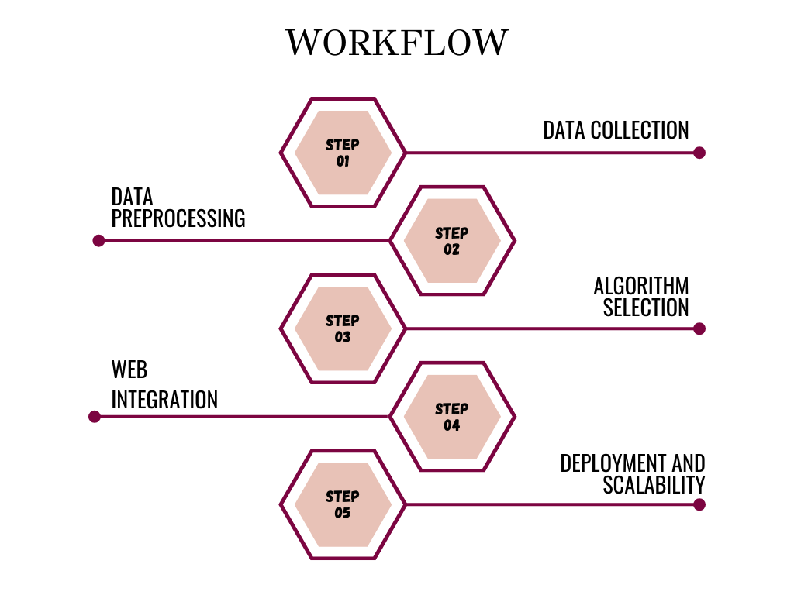

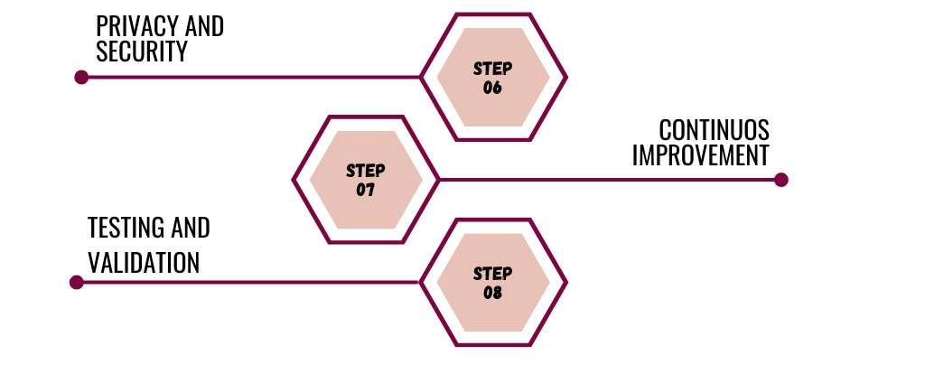

1. **OUTCOMES**

**Clinical Decision Support:**

The integration of patient case similarity analysis into healthcare practices offers a wealth of benefits for healthcare professionals. It serves as a vital tool in clinical decision support, empowering medical practitioners with valuable insights into similar patient cases. By drawing on a database of comparable cases, healthcare professionals can make more informed clinical decisions. This, in turn, aids in selecting the most appropriate treatment options and predicting likely outcomes for the patient under their care. Such a data-driven approach enhances the precision and efficacy of medical decision-making, ultimately leading to improved patient care and outcomes.

**Personalized Medicine:**

One of the most promising outcomes of patient case similarity analysis is the advancement of personalized medicine. This innovative approach hinges on the comprehensive analysis of a patient's medical history, symptoms, and genetic information. By identifying similar patient cases with a high degree of relevance, the healthcare system can tailor treatment plans and recommendations to the individual patient. This individualization of care represents a paradigm shift in healthcare, aligning treatments with each patient's unique needs. It promises not only better health outcomes but also a more patient-centered and efficient healthcare system.

**Clinical Trial Recruitment:**

Patient case similarity analysis plays a pivotal role in clinical trial recruitment, a process vital to the development of cutting-edge medical treatments and therapies. Identifying similar patient cases simplifies and streamlines the recruitment of eligible participants for clinical trials. Matching individuals with specific characteristics to trial requirements ensures that the trials are conducted with the most relevant and representative participant groups. This approach guarantees that the results of clinical trials are both accurate and applicable, advancing medical research and expediting the development of new treatments.

**Disease Diagnosis and Prognosis:**

In the realm of disease diagnosis and prognosis, patient case similarity analysis stands as a game-changer. By assessing the similarity between a patient's case and a database of comparable cases with known outcomes, early disease diagnosis becomes more attainable. Moreover, the accuracy of disease prognosis is significantly improved, as a patient's condition is evaluated in the context of similar cases. This approach aids in the early identification of diseases, offering a critical advantage in timely intervention. Furthermore, it provides a more nuanced understanding of disease progression, leading to more accurate prognoses and the optimization of treatment strategies. Patient case similarity analysis is, therefore, a cornerstone in the ongoing battle to enhance healthcare outcomes and patient well-being.

**6. TIMELINE OF THE PROJECT/ PROJECT EXECUTION PLAN**

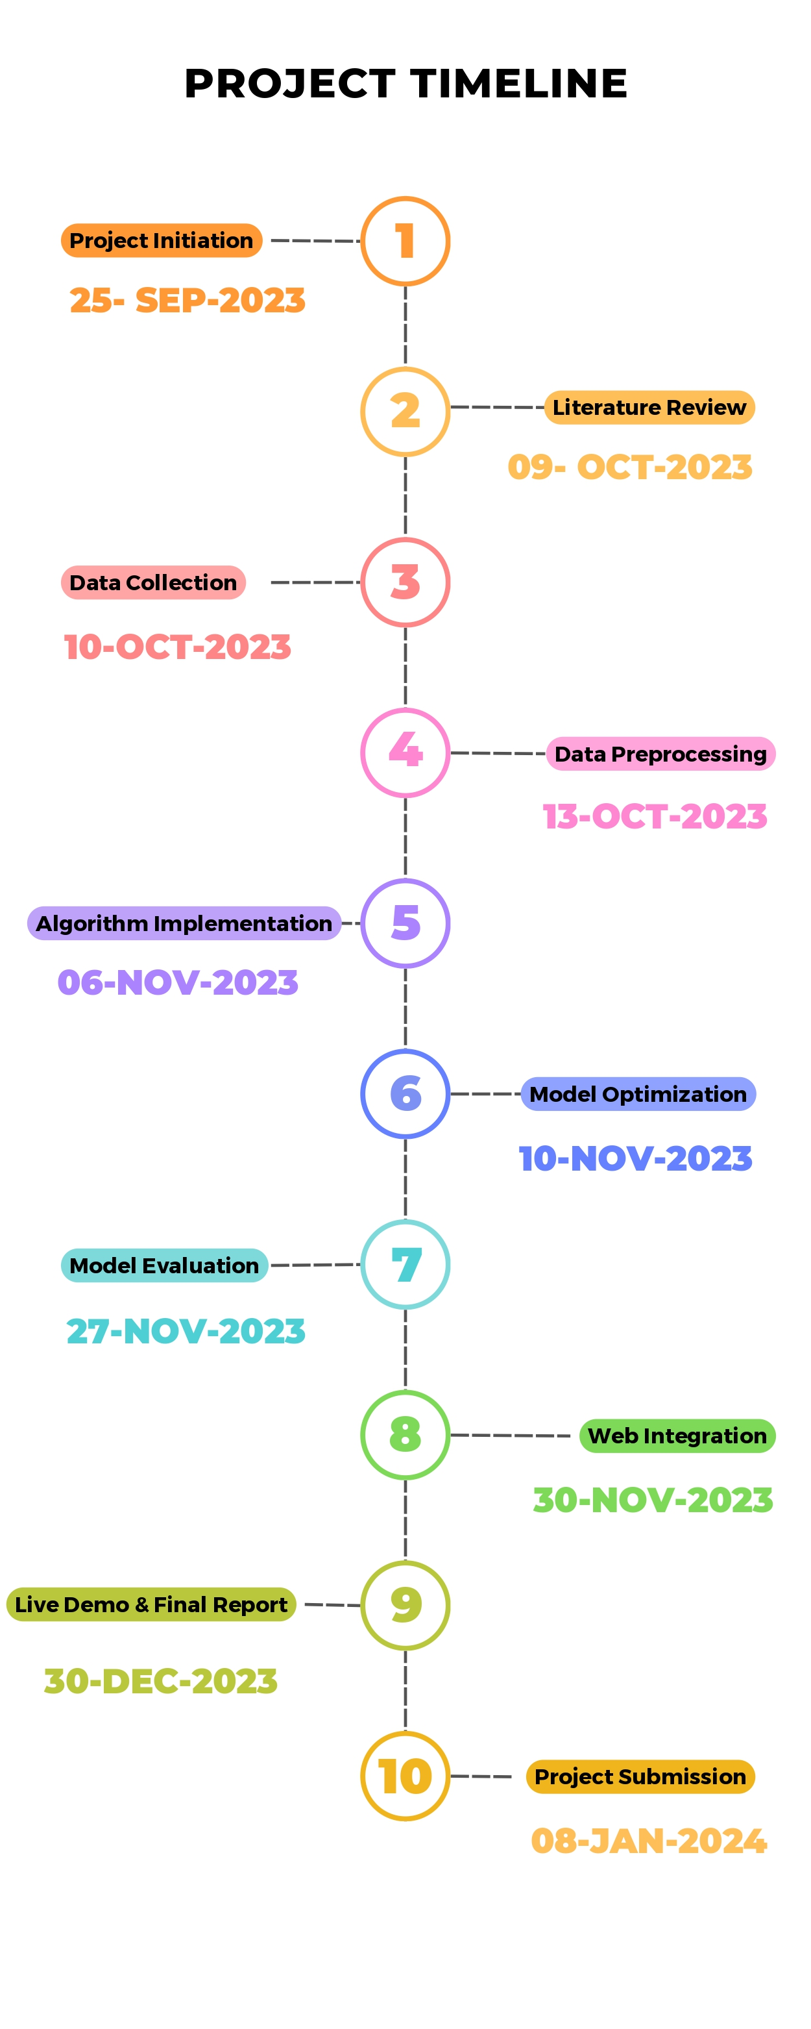

**7.CONCLUSION**

In conclusion, the proposal for "Disease Similarity Prediction using Machine Learning and a Web Application" presents a groundbreaking opportunity to reshape the landscape of disease-related research and healthcare practices. The project's multifaceted approach, rooted in advanced machine learning techniques, holds the promise of ushering in a new era in medical science and patient care. The potential benefits that this project brings to the table, coupled with its interdisciplinary nature and ethical considerations, signify its capacity to leave an indelible mark on the medical field. Ultimately, this has the potential to enhance the quality of healthcare and significantly improve patient outcomes.

One of the project's standout features is its utilization of complex machine learning models, which have consistently demonstrated promising accuracy in predicting disease similarities. This predictive capacity is not merely an academic achievement; it directly addresses the core objectives of this project are early disease recognition and diagnosis. Early-stage disease identification is a pivotal aspect of healthcare, as it can be the difference between life and death. By employing these intricate models, the project contributes significantly to the noble cause of saving lives by identifying diseases in their nascent stages.

The synthesis of data-driven insights, state-of-the-art technology, and a user-friendly web application is poised to empower both healthcare professionals and individuals seeking to take charge of their health. This holistic approach to healthcare, which fosters early intervention and informed decision-making, stands as a beacon of hope in the ever-evolving medical landscape. By bridging the gap between research and practice, this project not only advances our understanding of diseases but also provides practical solutions to enhance healthcare delivery.

As we move forward, the journey of this project offers not only a glimpse into the possibilities of machine learning in healthcare but also a testament to the unwavering commitment to the well-being of individuals and communities. In this era of rapid technological advancement, "Disease Similarity Prediction using Machine Learning and a Web Application" emerges as a trailblazer, offering a brighter and healthier future for us all.

1. **REFERENCES**

* [1] Keniya, Rinkal and Khakharia, Aman and Shah, Vruddhi and Gada, Vrushabh and Manjalkar, Ruchi and Thaker, Tirth and Warang, Mahesh and Mehendale, Ninad, Disease Prediction From Various Symptoms Using Machine Learning (July 27, 2020). Available at SSRN: https://ssrn.com/abstract=3661426 or <http://dx.doi.org/10.2139/ssrn.3661426>.
* [2] Dinh A, Miertschin S, Young A, Mohanty SD. A data-driven approach to predicting diabetes and cardiovascular disease with machine learning. BMC Med Inform Decis Mak. 2019 Nov 6;19(1):211. doi: 10.1186/s12911-019-0918-5. PMID: 31694707; PMCID: PMC6836338.
* [3] Md. Ariful Islam, Md. Ziaul Hasan Majumder, Md. Alomgeer Hussein, Chronic kidney disease prediction based on machine learning algorithms, Journal of Pathology Informatics, Volume 14, 2023, 100189, ISSN 2153-3539, <https://doi.org/10.1016/j.jpi.2023.100189>.
* [4] Subasish Mohapatra, Sushree Maneesha, Prashanta Kumar Patra, Subhadarshini Mohanty, Heart Diseases Prediction based on Stacking Classifiers Model, Procedia Computer Science, Volume 218, 2023, Pages 1621-1630, ISSN 1877-0509, <https://doi.org/10.1016/j.procs.2023.01.140>.
* [5] Nazin Ahmed, Rayhan Ahammed, Md. Manowarul Islam, Md. Ashraf Uddin, Arnisha Akhter, Md. Alamin Talukder, Bikash Kumar Paul, Machine learning based diabetes prediction and development of smart web application, International Journal of Cognitive Computing in Engineering, Volume 2, 2021, Pages 229-241, ISSN 2666-3074, <https://doi.org/10.1016/j.ijcce.2021.12.001>.
* [6] A. Mir and S. N. Dhage, "Diabetes Disease Prediction Using Machine Learning on Big Data of Healthcare," 2018 Fourth International Conference on Computing Communication Control and Automation (ICCUBEA), Pune, India, 2018, pp. 1-6, doi: 10.1109/ICCUBEA.2018.8697439.
* [7] A. Tyagi, R. Mehra and A. Saxena, "Interactive Thyroid Disease Prediction System Using Machine Learning Technique," 2018 Fifth International Conference on Parallel, Distributed and Grid Computing (PDGC), Solan, India, 2018, pp. 689-693, doi: 10.1109/PDGC.2018.8745910.
* [8] D. Dahiwade, G. Patle and E. Meshram, "Designing Disease Prediction Model Using Machine Learning Approach," 2019 3rd International Conference on Computing Methodologies and Communication (ICCMC), Erode, India, 2019, pp. 1211-1215, doi: 10.1109/ICCMC.2019.8819782.
* [9] A. Nikam, S. Bhandari, A. Mhaske and S. Mantri, "Cardiovascular Disease Prediction Using Machine Learning Models," 2020 IEEE Pune Section International Conference (PuneCon), Pune, India, 2020, pp. 22-27, doi: 10.1109/PuneCon50868.2020.9362367.
* [10] P. S. Kohli and S. Arora, "Application of Machine Learning in Disease Prediction," 2018 4th International Conference on Computing Communication and Automation (ICCCA), Greater Noida, India, 2018, pp. 1-4, doi: 10.1109/CCAA.2018.8777449.